# Clustering Algorithm Analysis

# Naga Sai Prudhvi Balam

## Load the ‘cluster_data.npy’

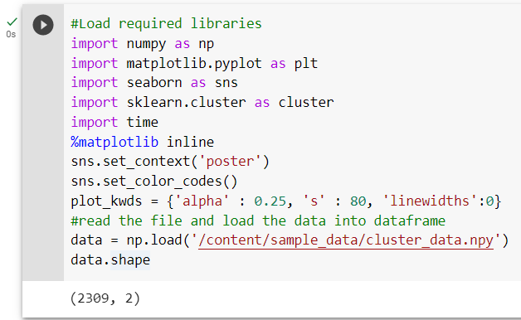

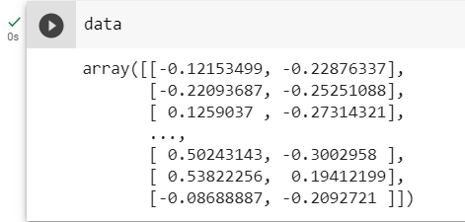

## Scatter plot the 'cluster_data.npy'

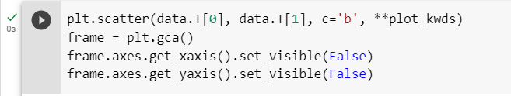

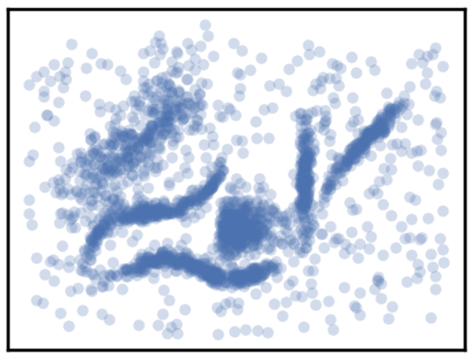

## Establish the plot clusters for each algorithm:

### **K means** :

plot_clusters(data, cluster.KMeans, (),{'n_clusters':6,'init':'kmeans++','random_state':42,

'n_init':'auto','max_iter':300,'tol':0.0001,'copy_x':True,'algorithm':'lloyd'})

**Parameters Considered for tuning :**

n_clusters

init

n_init

max_iter

algorithm

### **Affinity Propagation :**

plot_clusters(data, cluster.AffinityPropagation, (),{'damping':0.5, 'max_iter':200, 'convergence_iter':6,'copy':True, 'preference':None, 'affinity':'euclidean', 'verbose':False, 'random_state':42})

**Parameter Considered for tuning :**damping

max_iter

convergence_iter

preference

affinity

### **Mean Shift :**

plot_clusters(data, cluster.MeanShift,(),{'bandwidth':None, 'seeds':None, 'bin_seeding':False, 'min_bin_freq':1, 'cluster_all':True, 'n_jobs':None, 'max_iter':300})

**Parameter Considered for tuning :**

bandwidth

cluster_all

bin_seeding

min_bin_freq

### **Spectral Clustering :**

plot_clusters(data, cluster.SpectralClustering,(),{'n_clusters':6, 'eigen_solver':None, 'n_components':None, 'random_state':None, 'n_init':10, 'gamma':1.0, 'affinity':'rbf',

'n_neighbors':20, 'eigen_tol':'auto', 'assign_labels':'kmeans', 'degree':3, 'coef0':1, 'kernel_params':None, 'n_jobs':None, 'verbose':False})

**Parameter Considered for tuning :**

n_clusters

eigen_solver

n_components

gamma

affinity

### **Agglomerative Clustering :**

plot_clusters(data, cluster.AgglomerativeClustering,(),{'n_clusters':6, 'affinity':'deprecated', 'metric':None, 'memory':None, 'connectivity':None,

'compute_full_tree':'auto', 'linkage':'ward', 'distance_threshold':None, 'compute_distances':False})

**Parameter Considered for tuning :**

n_clusters

linkage

### **HDBSCAN :**

plot_clusters(data, hdbscan.HDBSCAN, (), {'min_cluster_size':15,'min_samples':15,'metric':'manhattan','p':2,'algorithm':'best','leaf_size':40,'alpha':1.0,'cluster_selection_method':'eom','cluster_selection_epsilon':0.0,})

**Parameters Considered for tuning :**

min_cluster_size

min_samples

metric

cluster_selection_method

# Set the parameter values for Clustering Algorithms:

|  |  |  |  |
| --- | --- | --- | --- |
| Algorithm | Parameter | Values | Justification |
| **k means** | n_clusters | 6 | From the scatterplot, we can see that the possible number of clusters is 6.So let us try to cluster data using K means and see whether we can get similar clusters as we see with our naked eye. |
| init | {‘k-means++’, ‘random’} | These are the initialization methods which are useful to select the initial cluster centroids. The random method assigns the centroids randomly whereas K means uses probability distribution which speeds up the convergence.  ***(sklearn.cluster.KMeans, 2023)*** |
| n_init | 10,1 | This value is selected based on initialization method. We choose 10 for random and 1 for k means initialization.  ***(sklearn.cluster.KMeans, 2023)*** |
| max_iter | 100,200,300 | The max iterations that we want for each run. We tune it based on the complexity of the problem.  ***(sklearn.cluster.KMeans, 2023)*** |
| random_state | 42 | We need the random seed to be set to an integer value to have the consistent clusters for each set of parameters.  ***(sklearn.cluster.KMeans, 2023)*** |
| algorithm | {“lloyd”, “elkan”} | We would be considering different algorithm types to see the efficient one.’lloyd’ is the most preferred as it’s an Expectation-Maximization algorithm whereas ‘elkan’ is more efficient on some datasets which has well defined clusters but is memory intensive.  ***(sklearn.cluster.KMeans, 2023)*** |

|  |  |  |  |
| --- | --- | --- | --- |
| Algorithm | Parameter | Values | Justification |
| **Affinity Propagation** | damping | Range from [0.5,1) | Damping controls the extent to which the **new information(pairwise similarity values between the data points)** is considered over the **current information(responsibility and availability values from the previous iteration)**.This helps prevents oscillations and improve the convergence. The damping value close to 1 means the new information is given more weight. ***(sklearn.cluster.AffinityPropagation, 2023)***  ***(Affinity Propagation in ML, 2023)*** |
| preference | Range from  [-1,-50] | This value defines the number of clusters generated by the algorithm. Higher preference values would generate more clusters whereas the lower values create less clusters.  ***(sklearn.cluster.AffinityPropagation, 2023)***  ***(Affinity Propagation in ML, 2023)*** |
| convergence_iter | {15,20,25} | This determines the number of iterations with no change in the number of estimated clusters before the algorithm terminates. A good value to start with is 15 and we check by increasing the values until 25 to see if there are any cluster variations.  ***(sklearn.cluster.AffinityPropagation, 2023)*** |
| affinity | {‘euclidean’, ‘precomputed’} | To calculate the pairwise similarities between data points, Affinity Propagation requires specification of the distance metric. The selection of an appropriate metric is influenced by the intrinsic characteristics of the data. We prefer to use Euclidean distance which uses the negative squared euclidean distance between points.  ***(sklearn.cluster.AffinityPropagation, 2023)*** |
| max_iter | {100,200,300} | The max iterations that we want for each run. We tune it based on the complexity of the problem.  ***(sklearn.cluster.AffinityPropagation, 2023)*** |

|  |  |  |  |
| --- | --- | --- | --- |
| Algorithm | Parameter | Values | Justification |
| **Mean Shift** | bandwidth | Range [0.1,0.3) | The bandwidth value is used to control the kernel size by density estimation process. Larger neighborhoods give fewer clusters whereas lower give more.  To find the optimum bandwidth value to get the reasonable clustering, I have got an initial value to choose by using **estimate_bandwidth** function from **sklearn.cluster** and tried multiple values by trial-and-error method and come up with that range where varying the bandwidth changes clustering pattern.  ***(sklearn.cluster.MeanShift, 2023)***  ***(Understanding Mean Shift Clustering, 2023)*** |
| cluster_all | {'True','False'} | This parameter when set to True assigns the outliers to the nearest possible cluster and when set to False it considers all the outliers as a single cluster all together.  ***(sklearn.cluster.MeanShift, 2023)*** |
| bin_seeding | {'True','False'} | This helps in grouping the data points into bins before computing the mean shift vectors using the kernel function and bandwidth. Using this parameter can help speed up the algorithm as it only requires fewer seeds to compute.  ***(sklearn.cluster.MeanShift, 2023)*** |
| min_bin_freq | range(1 to 200) | This parameter specifies the min number of data points required to form a bin. These values are only applicable when bin seeding is set to True.  ***(sklearn.cluster.MeanShift, 2023)*** |

|  |  |  |  |
| --- | --- | --- | --- |
| Algorithm | Parameter | Values | Justification |
| **Spectral Clustering** | n_clusters | 6 | Let us try to cluster data using Spectral clustering and see whether we can get the similar clusters as we see with our naked eye. |
| eigen_solver | {‘arpack’, ‘lobpcg’, ‘amg’} | This parameter specifies the strategy to compute the eigen values of the Laplacian matrix. To use amg solver, we need pyamg needs to be installed. ***(sklearn.cluster.SpectralClustering, 2023)*** |
| n_components | Range[2,10] | It mentions the number of eigen vectors to embed the data into lower dimensional space. To get the optimal value, I have tried to change the values in the range of 2 to 10 and check the cluster patterns. ***(sklearn.cluster.SpectralClustering, 2023)*** |
| affinity | {‘nearest_neighbors’,'rbf',‘precomputed’,‘precomputed_nearest_neighbors’} | This param is used to compute the **affinity matrix**(How close and similar two data points are in the space) and its value depends on the data set. If we have a clear cluster structure, using 'rbf' would be a good choice. However, we try other params to check how the clustering varies. ***(sklearn.cluster.SpectralClustering, 2023)***  ***(Spectral Clustering, 2023)*** |
| gamma | 0.1 to 1 | This value specifies the kernel coefficient for each affinity. The typical value of gamma is between 0.1 to 1.To find the optimal values, I used trial and error method.  ***(sklearn.cluster.SpectralClustering, 2023)*** |

|  |  |  |  |
| --- | --- | --- | --- |
| Algorithm | Parameter | Values | Justification |
| **Agglomerative Clustering** | n_cluster | 6 | Let us try clustering the data into 6 clusters using Agglomerative clustering and see whether we can get similar clusters as we see with our naked eye.  ***(sklearn.cluster.AgglomerativeClustering, 2023)*** |
| linkage | {‘ward’, ‘complete’, ‘average’, ‘single’} | The linkage criterion determines which distance to use between the newly formed clusters and the existing clusters. This particular criterion plays an integral role in identifying the pairs of clusters that need to be merged to optimize the clustering process.  ***(sklearn.cluster.AgglomerativeClustering, 2023)*** |

|  |  |  |  |
| --- | --- | --- | --- |
| Algorithm | Parameter | Values | Justification |
| **HDBSCAN** | min_cluster_size | {15,30,50} | The values represent the minimum number of data points to consider forming a cluster. It is one of the key parameters in HDBSCAN where larger value gives less clusters and smaller value gives more clusters. ***(HDBSCAN*¶, 2023)*** |
| min_samples | {1,15,30,60} | This param specifies the measure of how conservative the clustering to be and it helps change the density of a cluster. Increasing its value will declare more points as noise.  ***(HDBSCAN*¶, 2023)*** |
| metric | {'euclidean', 'l2', 'l1', 'manhattan', 'cityblock','minkowski','dice', 'hamming','correlation'} | This is the distance metric used to calculate the pairwise distance between the data points.  ***(Metrics¶, 2023)*** |
| cluster_selection_method | {'eom','leaf'} | The methods used to select the final set of clusters from the hierarchical clustering tree.  ***(HDBSCAN*¶, 2023)*** |

# Evaluating the Algorithms and Plotting the results :

## K-Means :

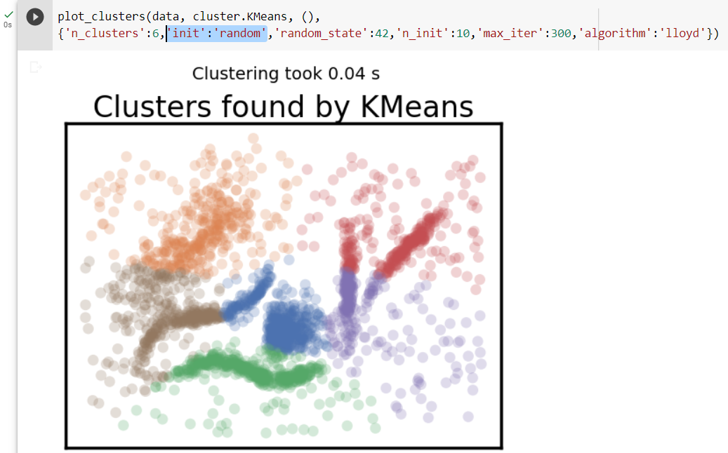

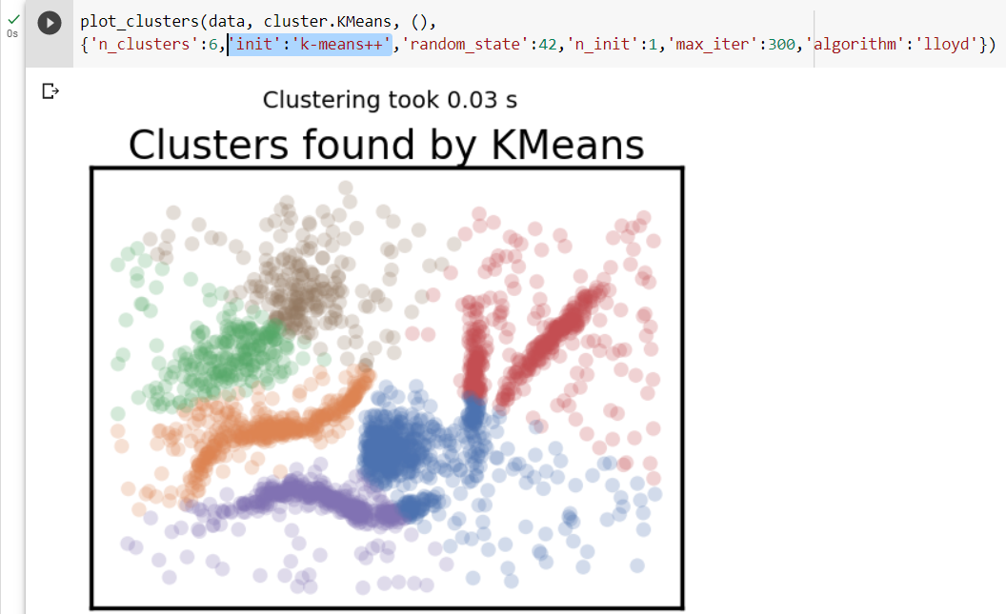

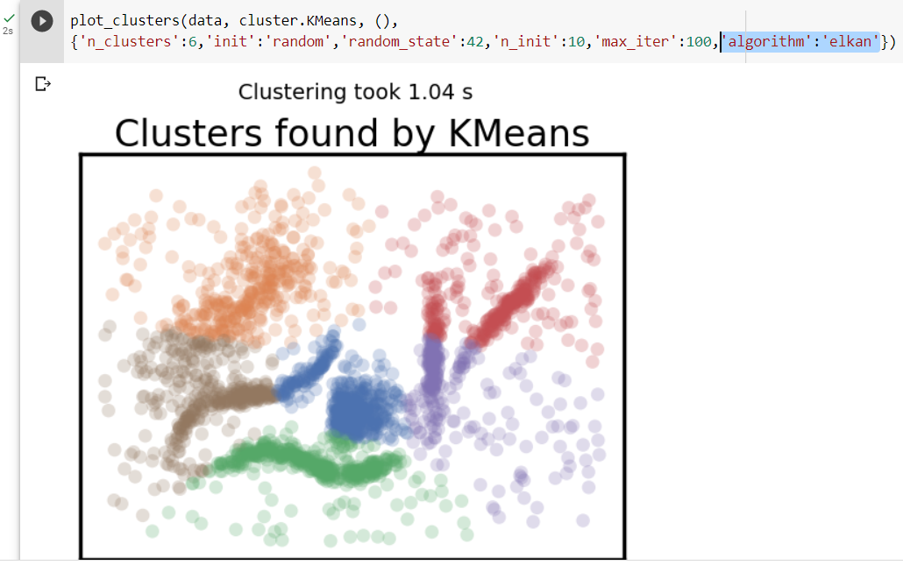

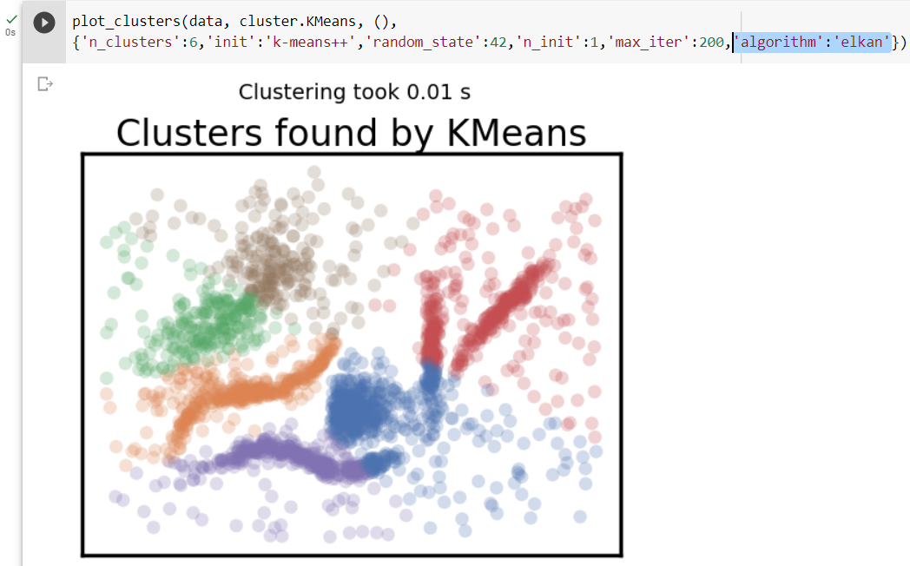

## Affinity Propagation:

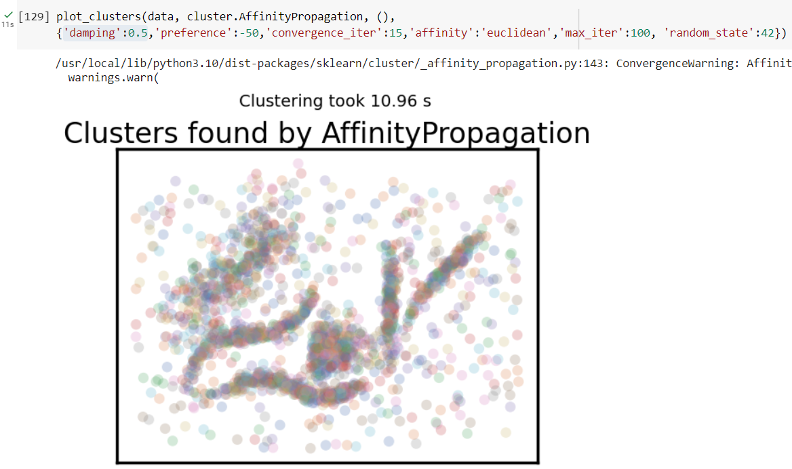

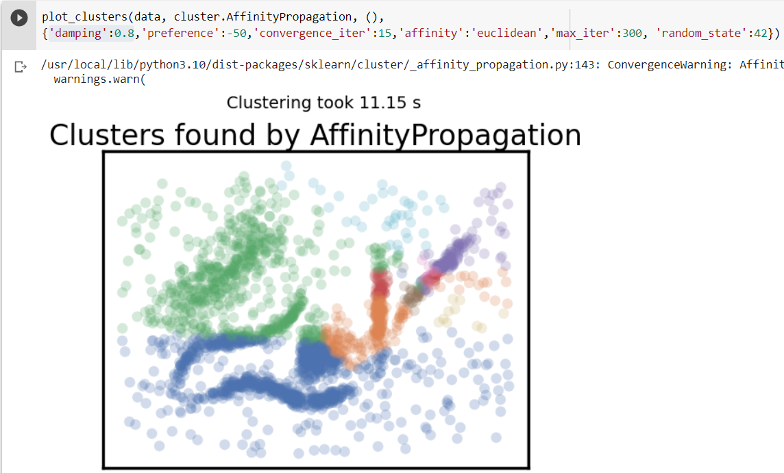

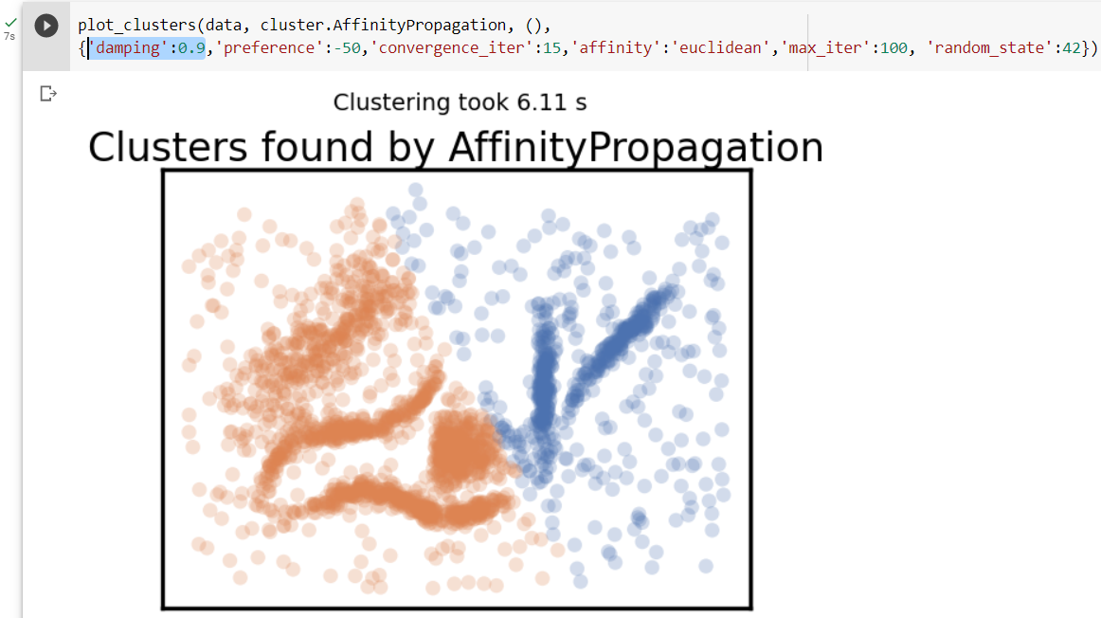

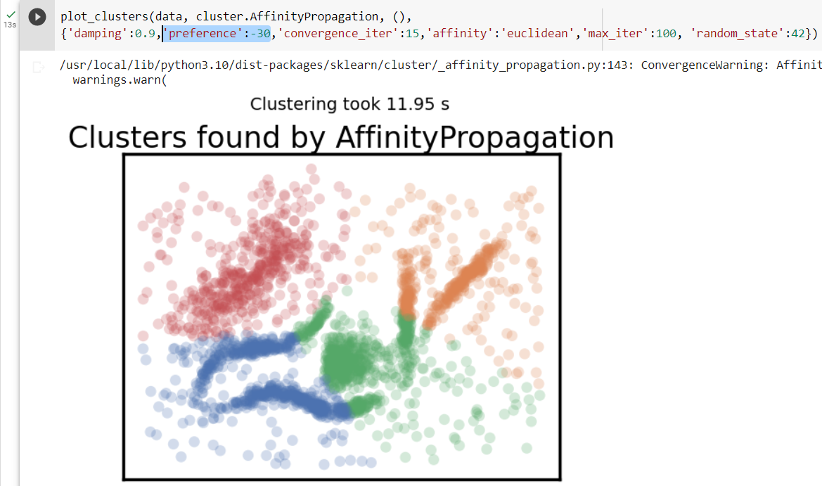

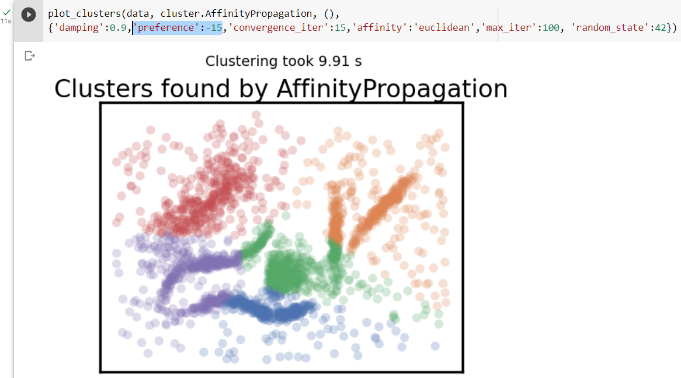

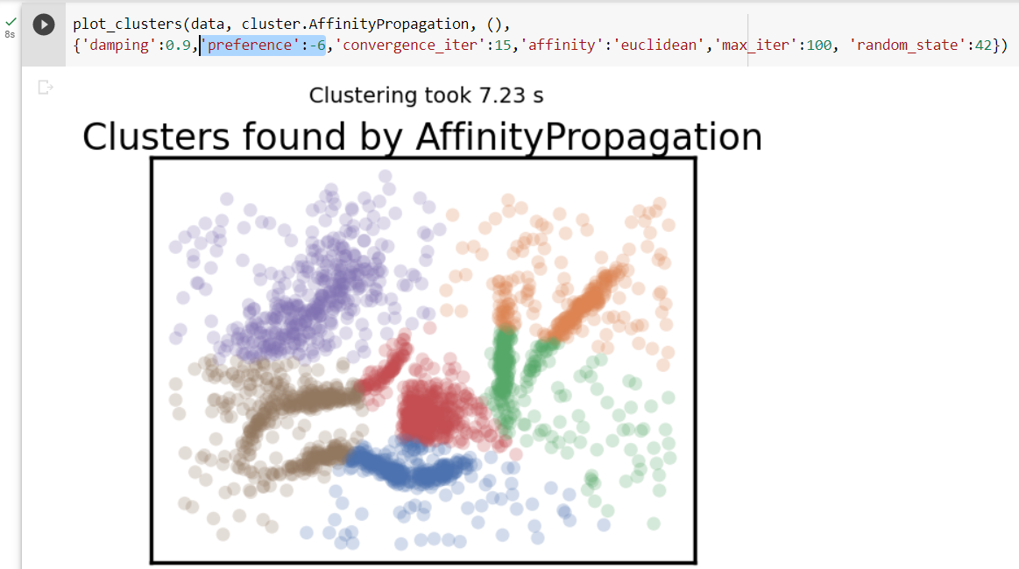

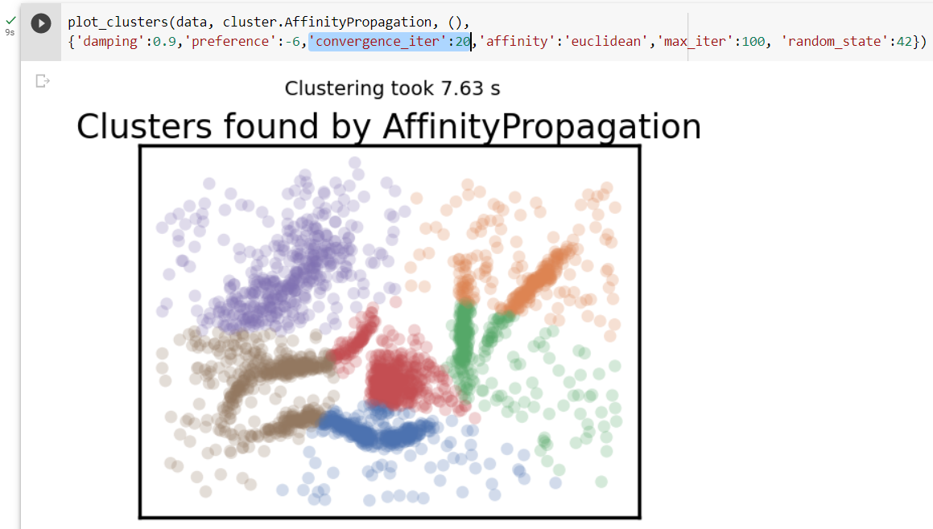

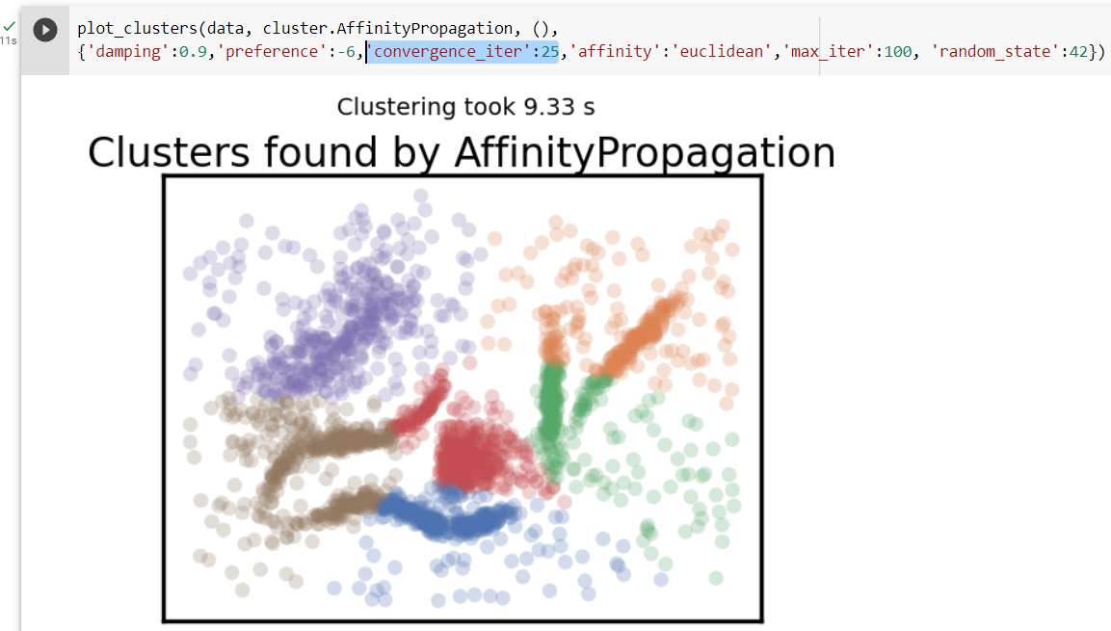

## Mean Shift :

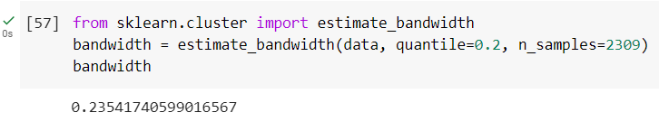

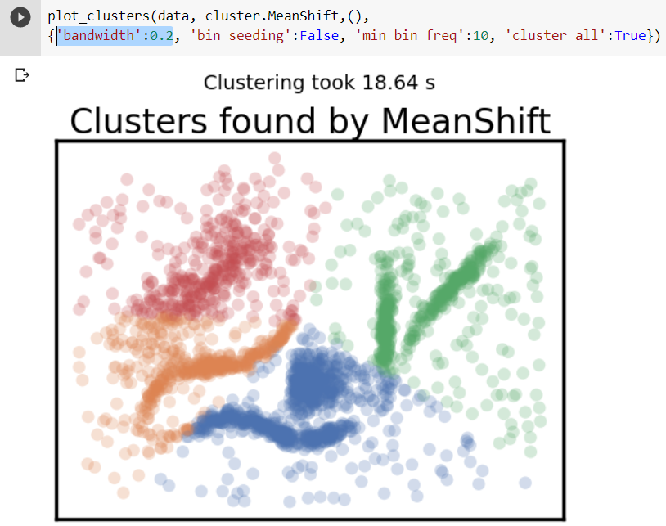

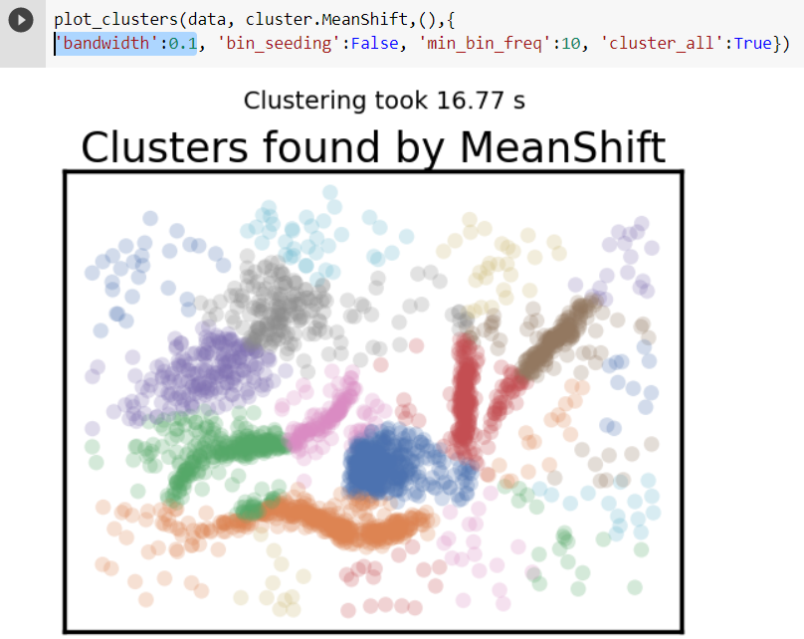

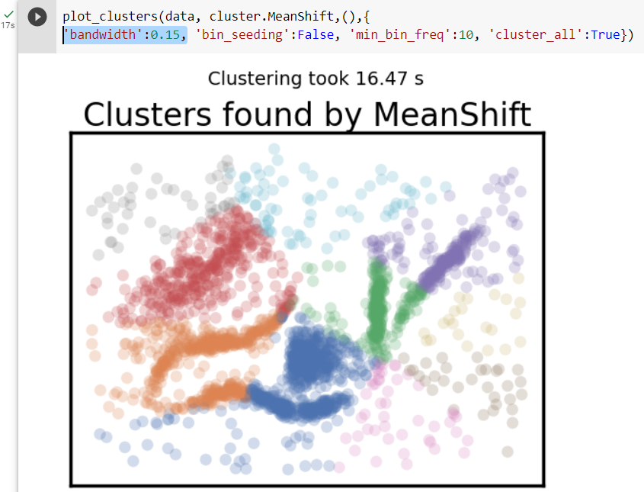

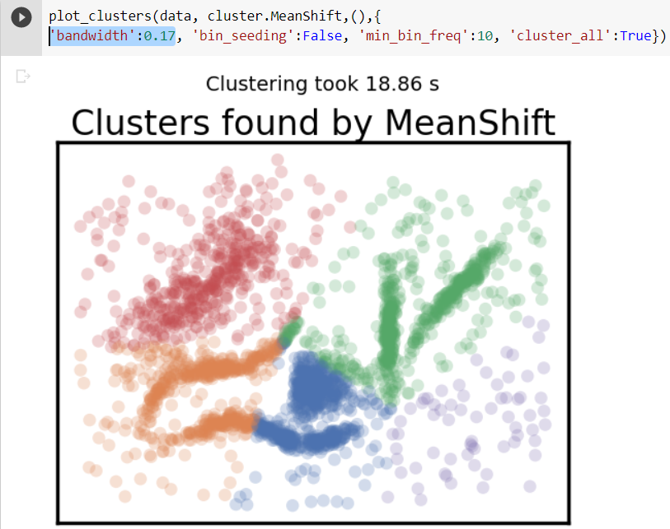

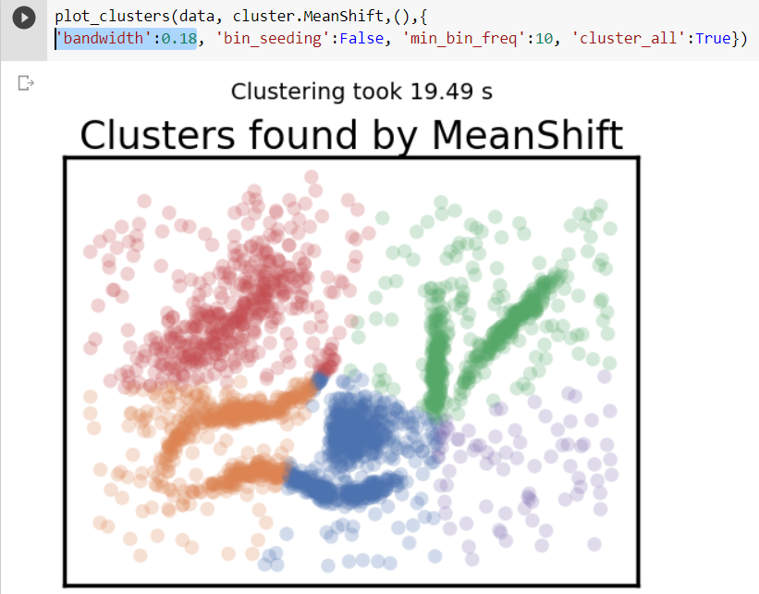

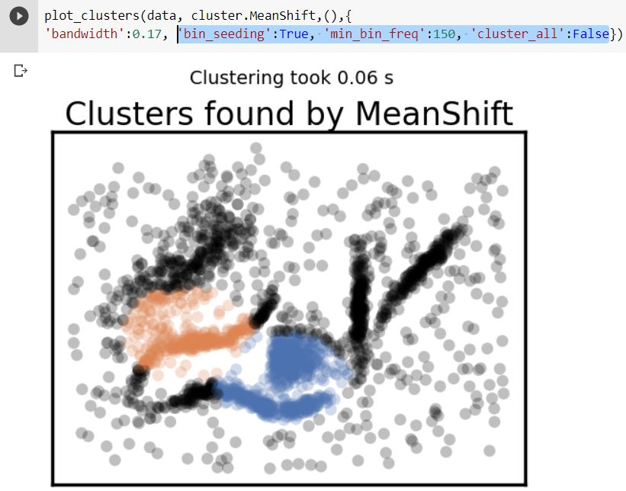

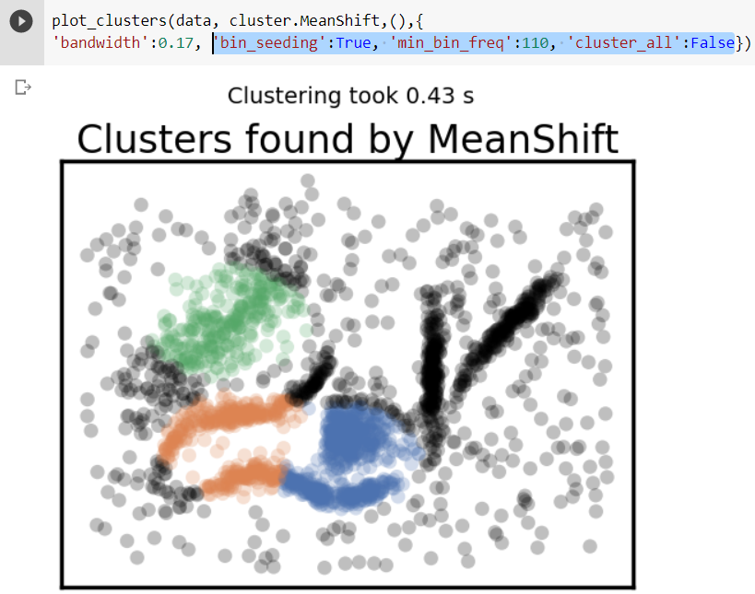

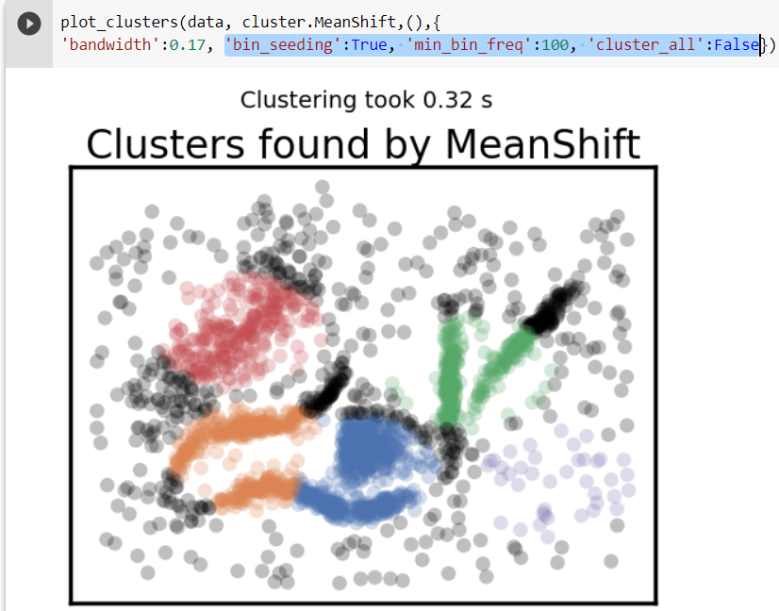

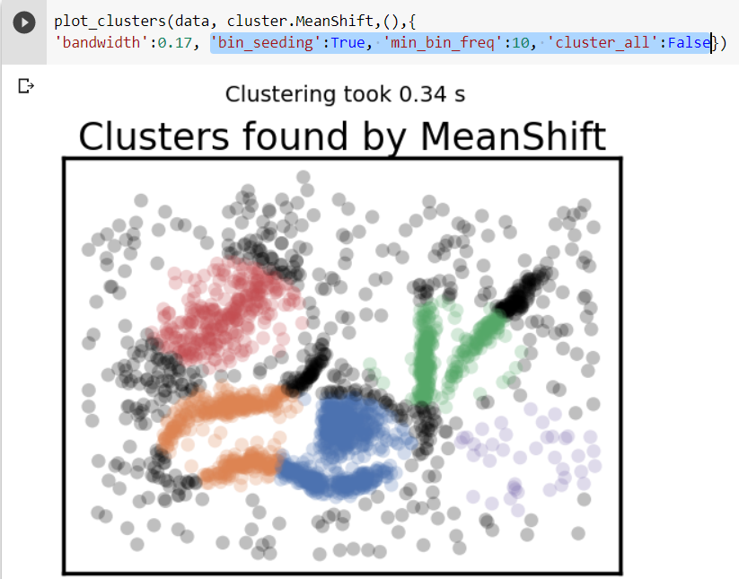

## Spectral Clustering:

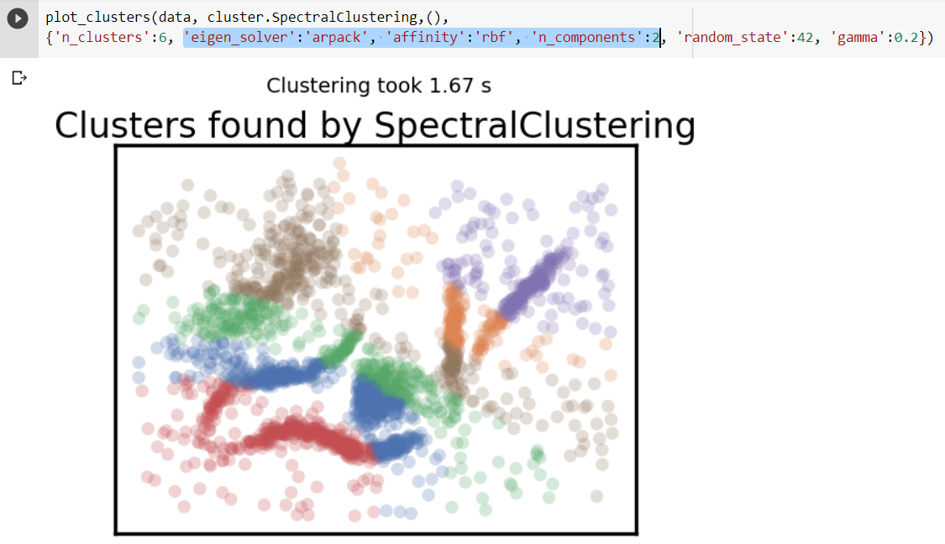

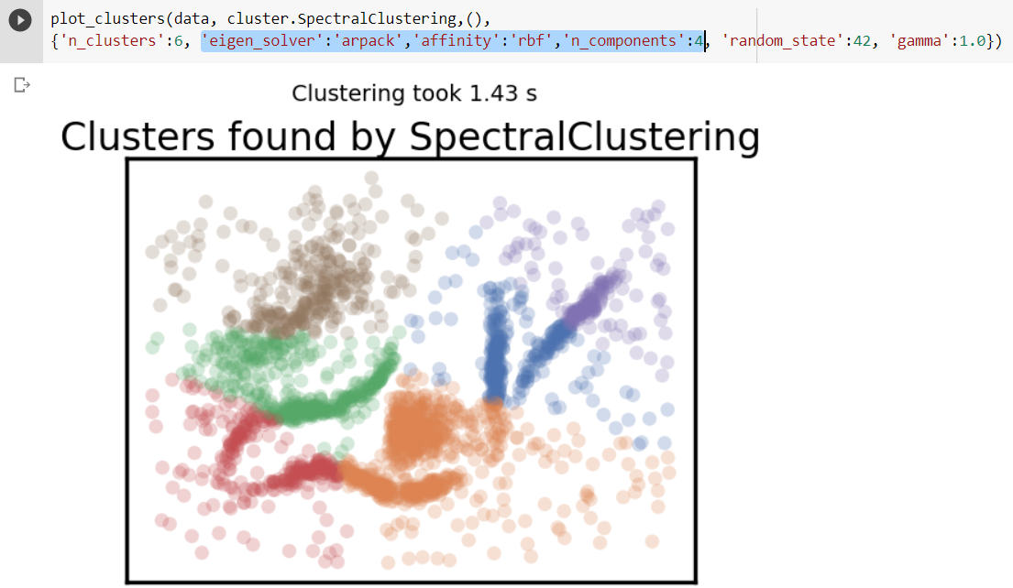

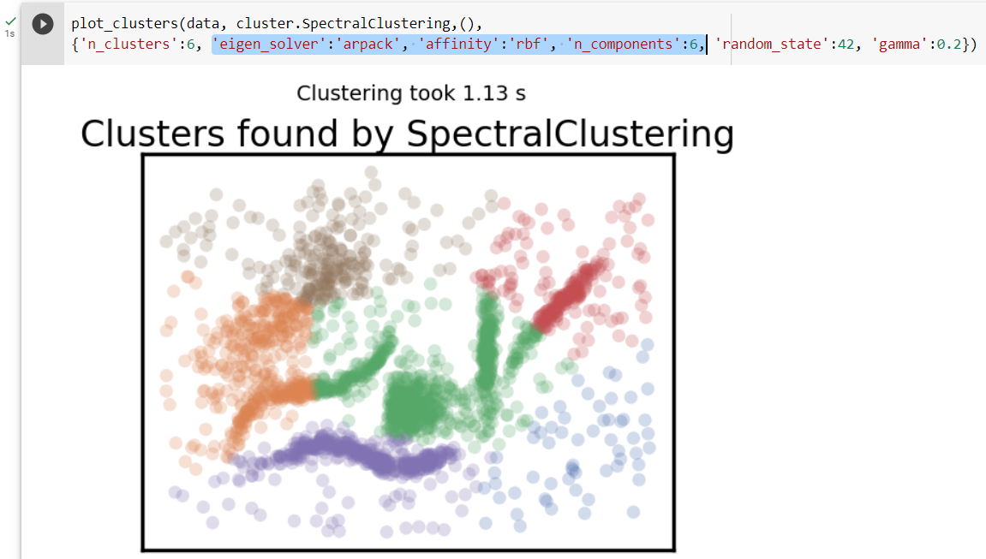

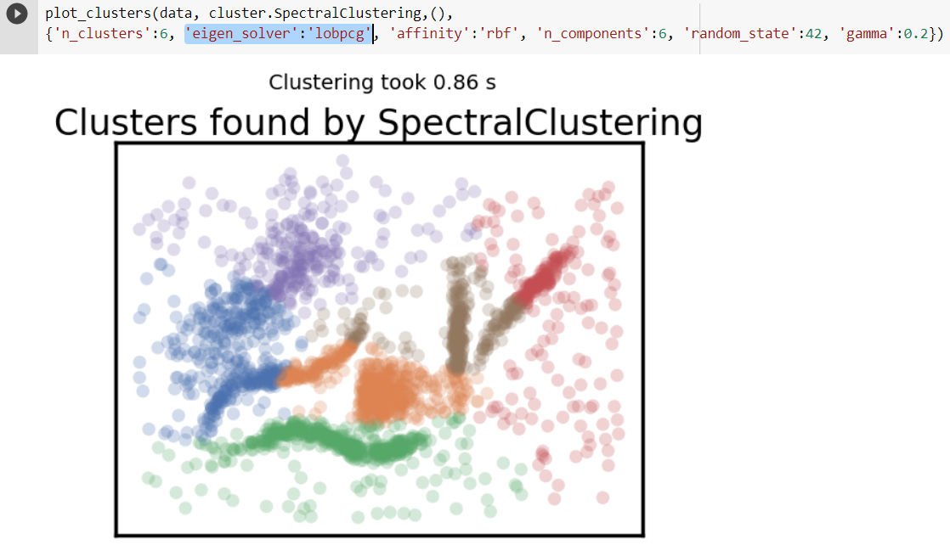

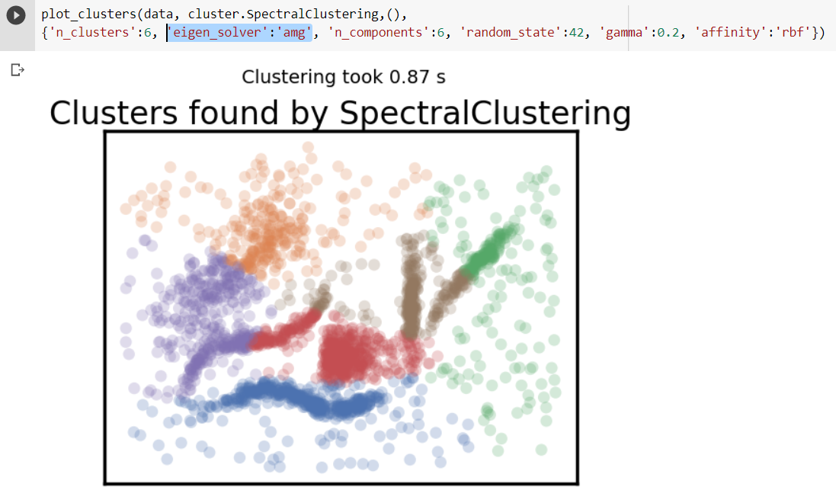

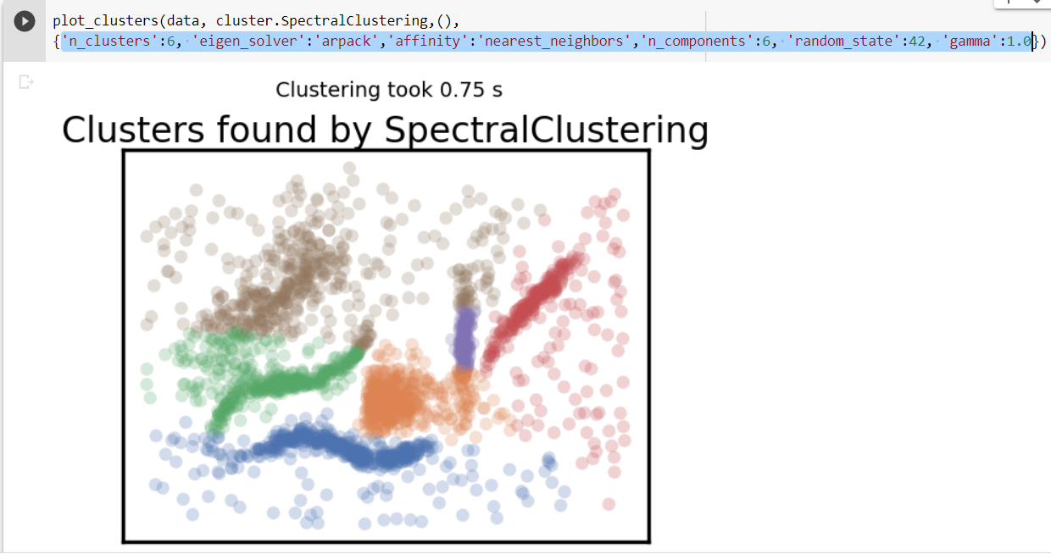

## Agglomerative Clustering:

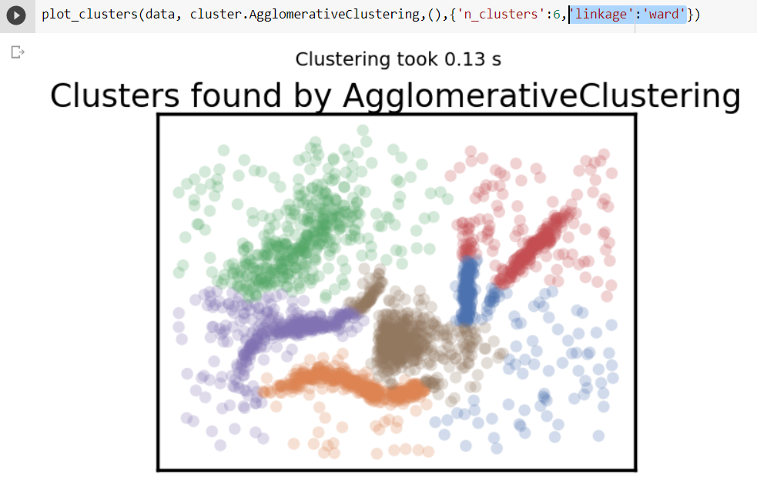

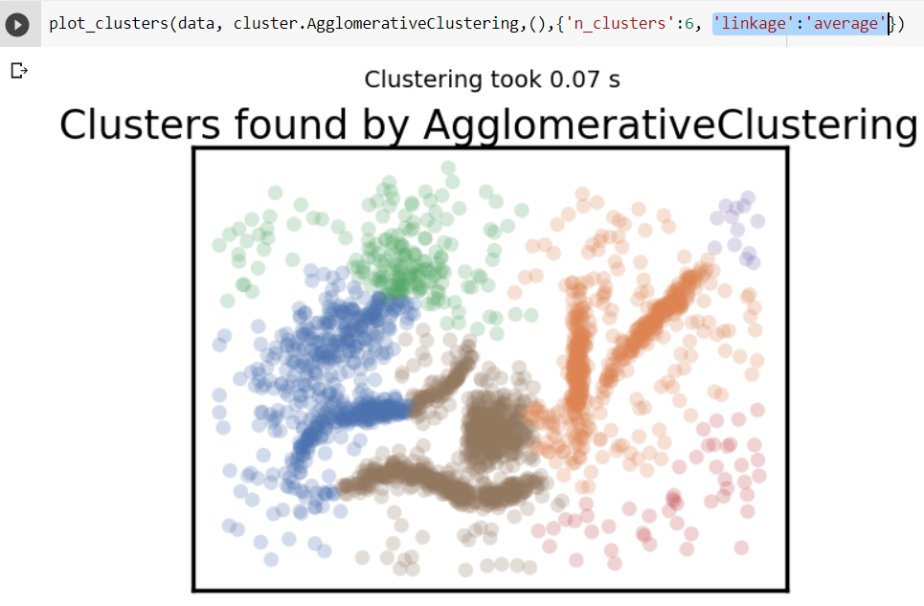

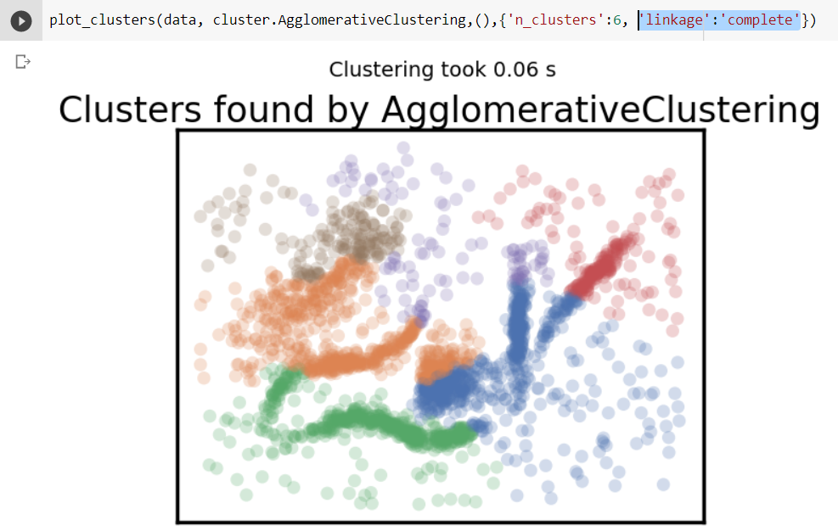

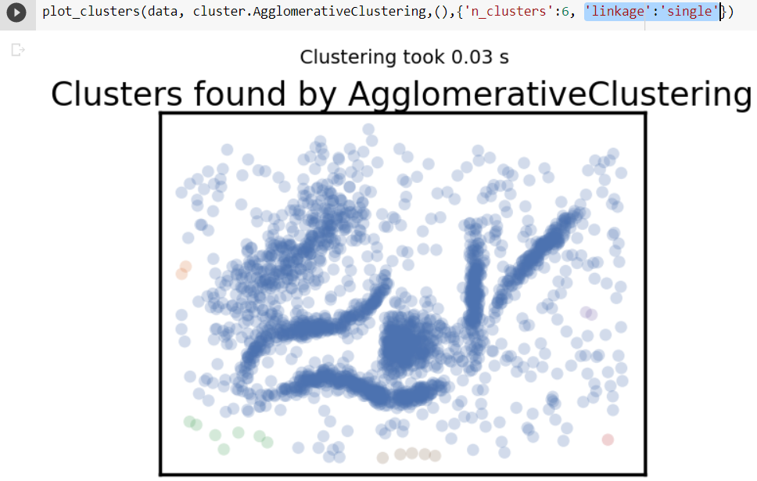

## HDBSCAN:

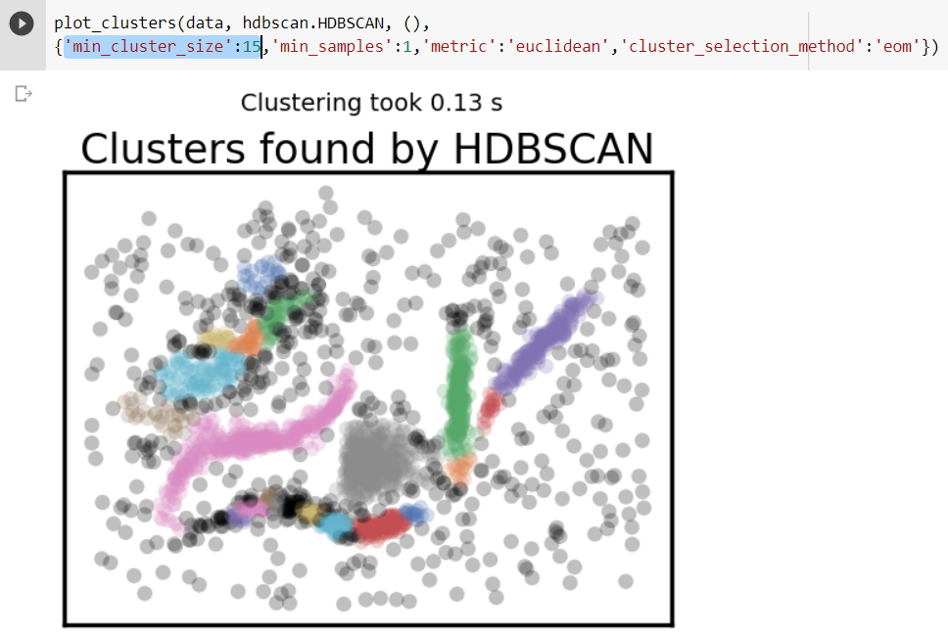

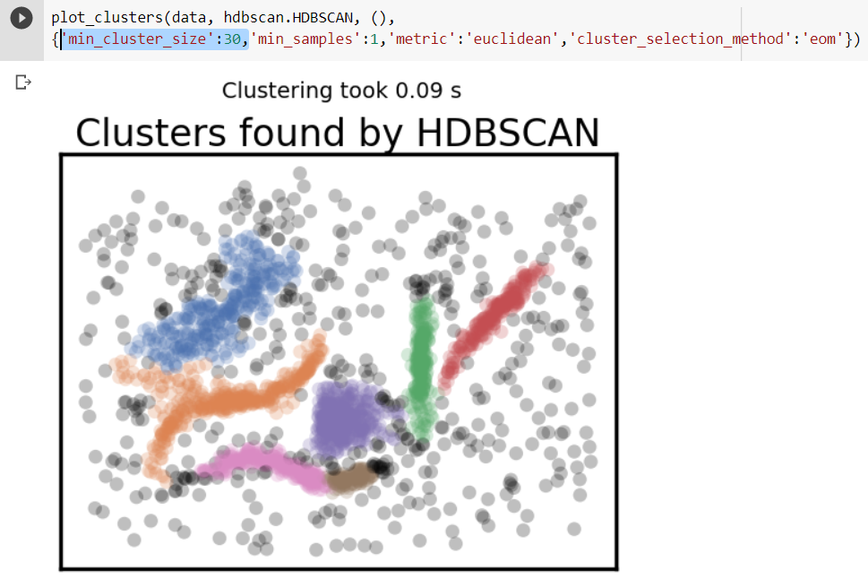

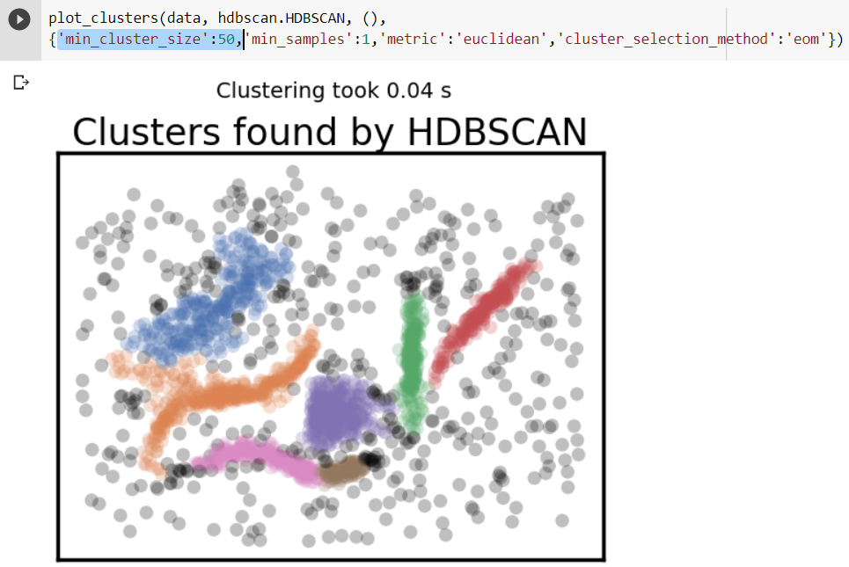

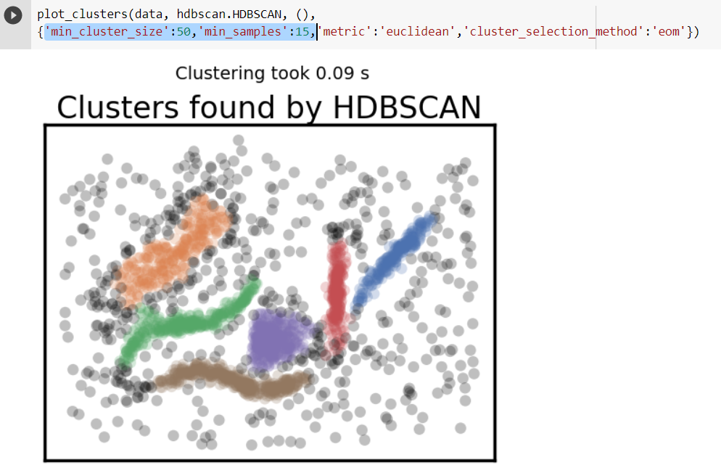

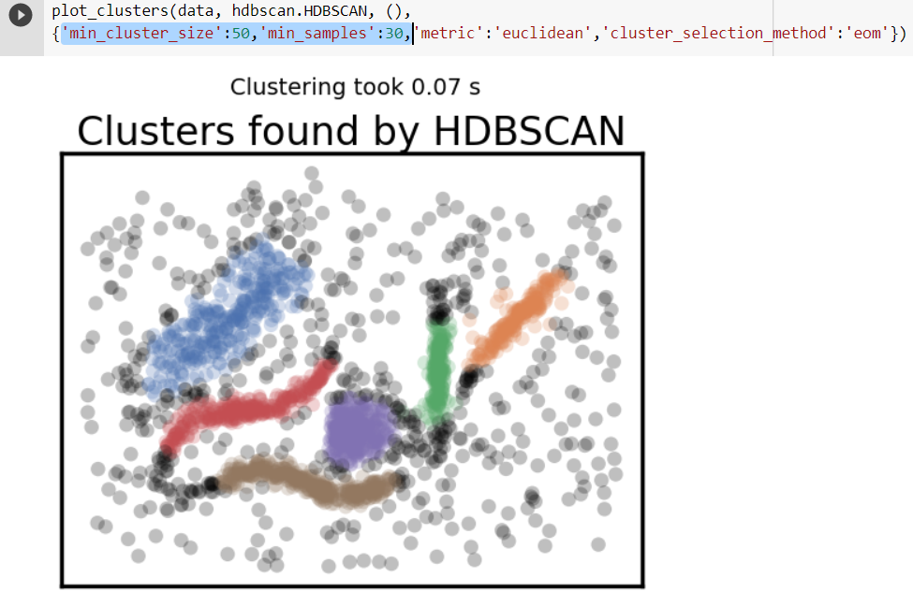

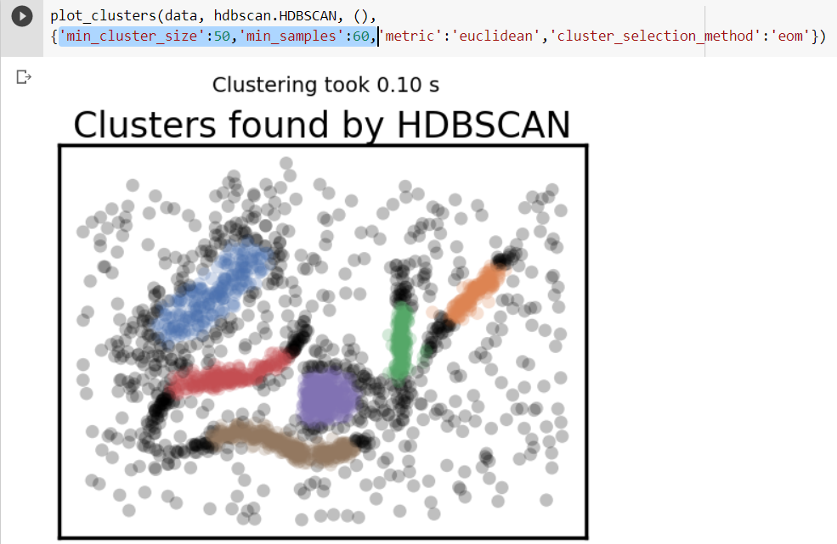

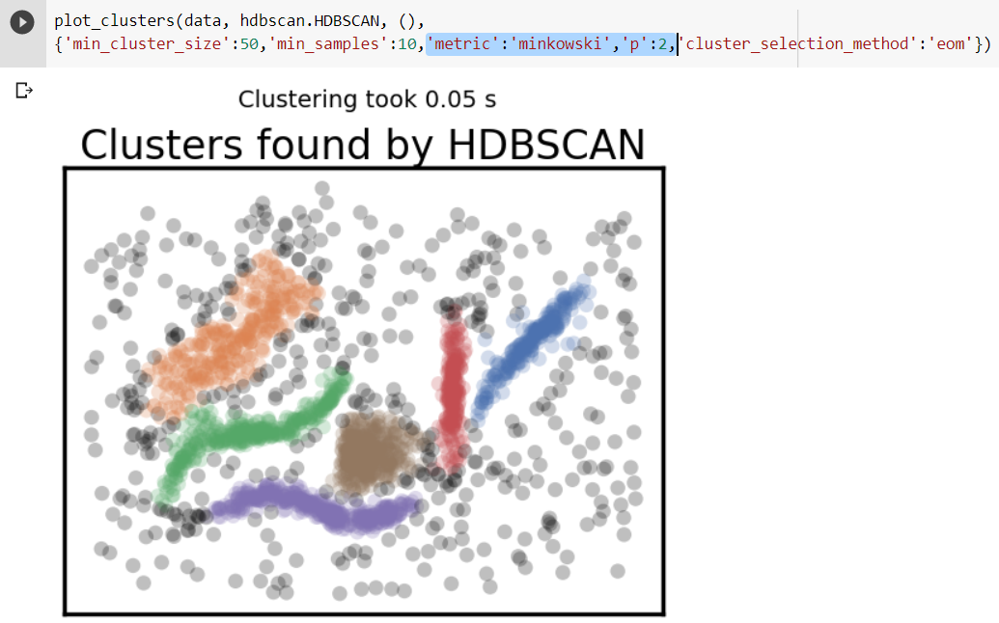

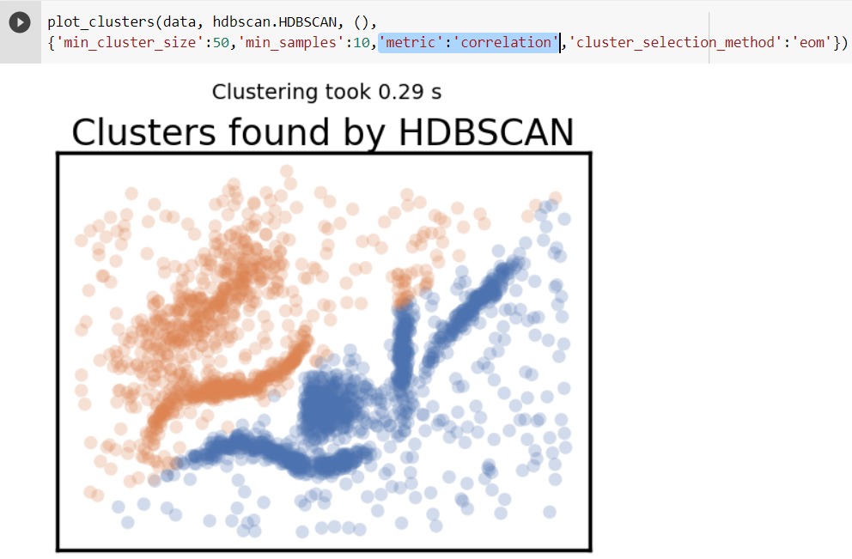

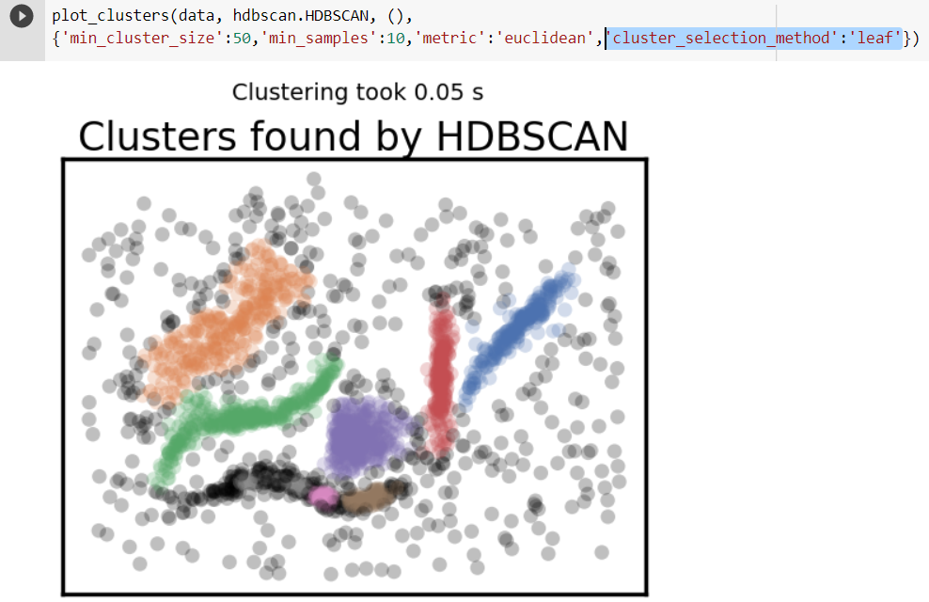

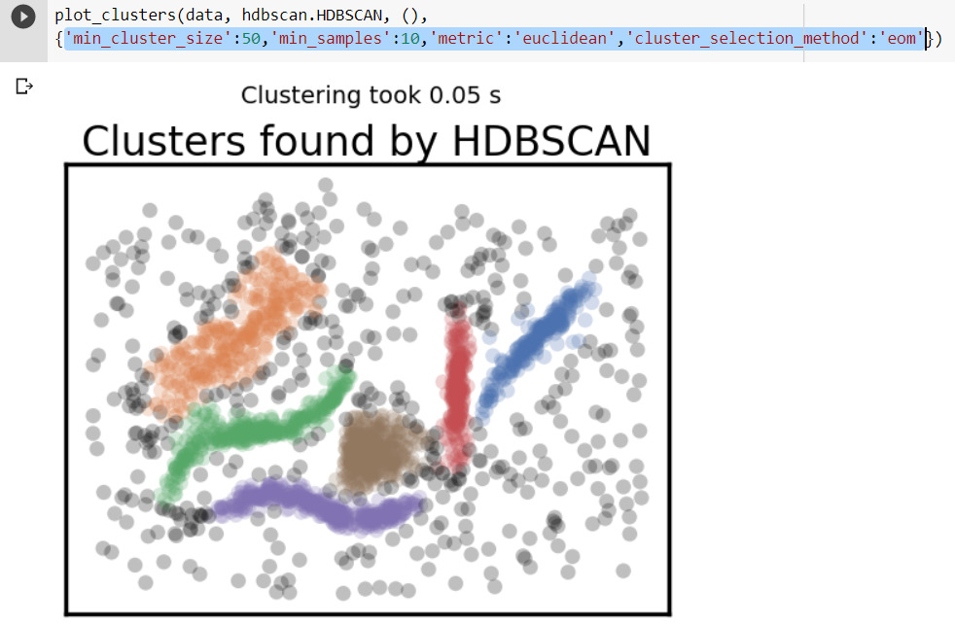

# Technical Report:

## K -means:

**Don’t be wrong** : K means gets lesser points in this segment as it can assign few points randomly to the clusters that they might not belong to.

**Intuitive Parameters** : The algorithm would be useful only if we have a clear distinct clusters seen in the dataset.

**Stability** : We can consider K-means as stable algorithm as we got similar clusters with different initializations.

**Performance:** it’s a simple, faster, and very efficient algorithm and preferred when there are large datasets.

**Best Param Values**:



Visually looking at the scatterplot of the dataset we can see 6 clusters. So, we defined n_clusters as 6 to check the clusters made by the algorithm. Another important parameter is the initialization method. Instead of using random method we use K means ++ which uses probability distribution to assign centroids.

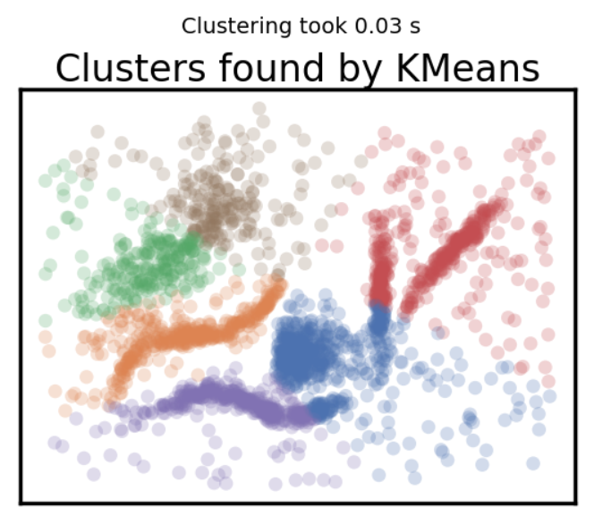

We see the clusters are made by slicing and grouping them into spherical shapes. The outliers or the noisy data points have been assigned to the clusters which are nearest to them which leads to false intuition and wrong data interpretation. However, the algorithm does rapid clustering.

Intra cluster distance is large as we have noisy data for few clusters and inter cluster distance is less as the clusters are just sliced and grouped.

## Affinity Propagation:

**Don’t be wrong:** Even the affinity propagation algorithm has data points being assigned to the groups which they don’t belong to.

**Intuitive Parameters:** Changing damping and preference values would change the number of clusters and the clustering patterns.

**Stability:** It is deterministic over runs

**Performance:** Its slow as compared to k means and not feasible using it on large datasets.

**Best Params**:



The damping and preference are the most important values which decide the cluster formations. The damping helps reduce the oscillations and improves the convergence. Considering its value as 0.9 means the new information is given more weight than the current one. Changing preference values of datapoints changes the number of clusters formed where higher value gives more clusters while smaller values form less clusters. I have tried changing the preference values so that we get 6 clusters.

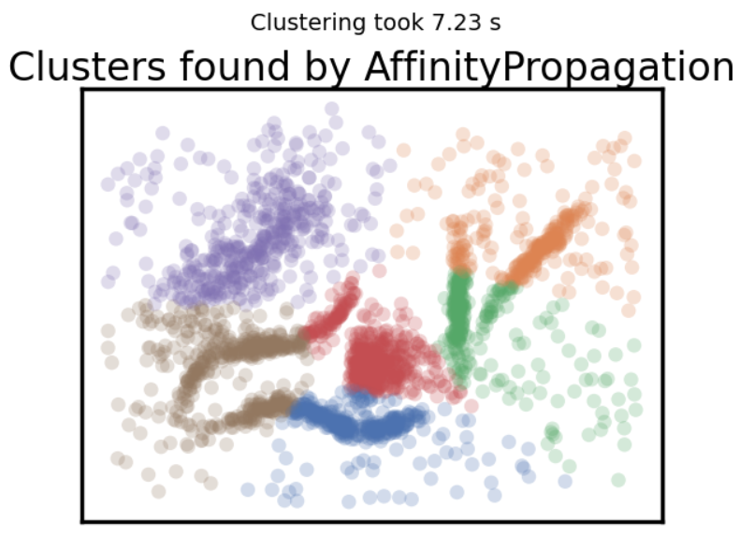

We see the clustering is like k means i.e., the dataset is partitioned and created globular clusters. The noisy data has been assigned to the nearest clusters instead of recognizing them as the outliers which leads to poor intuition of data from above clusters. Moreover, it takes a couple of seconds to generate the clustering results.

The inter cluster distance is lesser(clusters are close) as compared to intra cluster distances because of the outliers.

## Mean Shift:

**Don’t be wrong:** Good data points are considered as outliers as seen from the plot below.

**Intuitive Parameters:** Changing the bandwidth can result in cluster variations to a larger extent and setting cluster_all to false help us group all the outliers as a cluster.

**Stability:** The seeds are randomly initialized so the different runs may vary the clustering which makes it less stable.

**Performance:** it’s very slow in implementation if we need to initialize more seeds which makes it a weak point to use with scaled data sets.

**Best Params:**



The initial bandwidth value is known using estimate_bandwidth function and tried varying to get the optimal number of clusters. Changing the ‘bin_seeding’ to true improves the performance significantly as it needs fewer seeds to initialize and setting ‘cluster_all’ to False helps us group all the outliers.

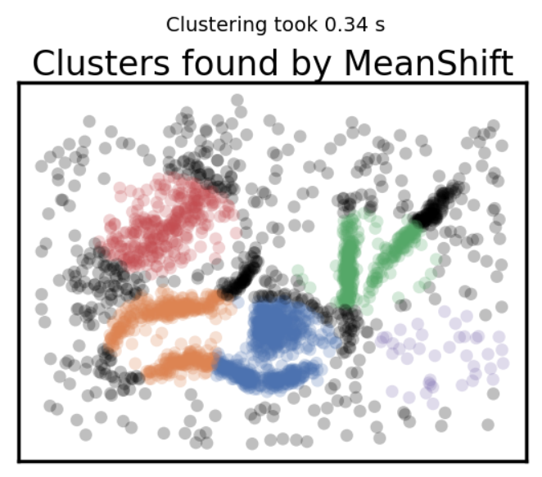

We see now the noisy data is eliminated but a few dense regions which might not probably be outliers are also considered as noise. The purple cluster doesn’t make any sense as it has no dense region which makes it feel like a cluster. It can cluster data fast but only when bin seeding is set to true otherwise it takes a while to generate results.

Intra Cluster distance is minimal as we now have dense clusters and inter cluster distance is increased as the clusters are bit far away.

## Spectral Clustering:

**Don’t be wrong:** We still see the partitioning and the noisy data embedded into clusters.

**Intuitive Parameters:** We need to specify the clusters so if we don’t have visible cluster patterns it would be a problem.

**Stability:** Its more stable as compared to K means.

**Performance:** It has a good computational speed of the algorithm as compared to others and can be scaled.

**Best Params:**



If we have well defined clusters patterns visible, using ‘rbf’ for affinity would be the best choice. The eigen solver is the method used to solve the eigen values and we don’t see any impact of it in cluster variations. Changing n_component and gamma values would change the cluster formations.

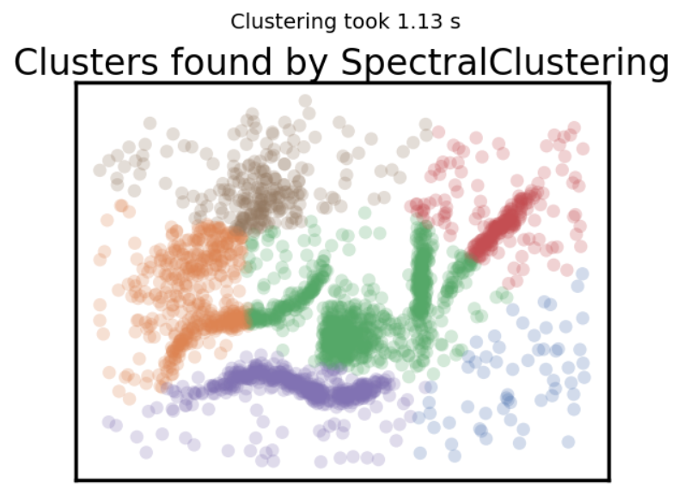

I see the clustering is done in a better way but for some clusters it includes part of the other cluster segment into it, and also we see the noisy data points are still there and embedded into cluster which gives us wrong interpretation of data. Its overall performance is good but needs to achieve more to have the desired clustering.

Here the intra clustering distance is more as compared to inter cluster distance because of the outliers.

## Agglomerative Clustering:

**Don’t be wrong:** We still have noisy data in clusters but don’t see globular cluster patterns.

**Intuitive Parameters:** Need to specify the no of clusters which make it bit tougher in EDA to find when you don’t have clear patterns.

**Stability:** It gives stable results over runs and cluster variations with parameters tuning can be seen using dendrograms.

**Performance:** It has a good performance score and can be scaled to use on larger datasets.

**Best Param:**



We specify the n_clusters as 6 as we have clear visible patterns on the original dataset and test to get similar clusters using Agglomerative Cluster. We use the Linkage type as ‘ward’ which minimizes the variance of the clusters being merged.

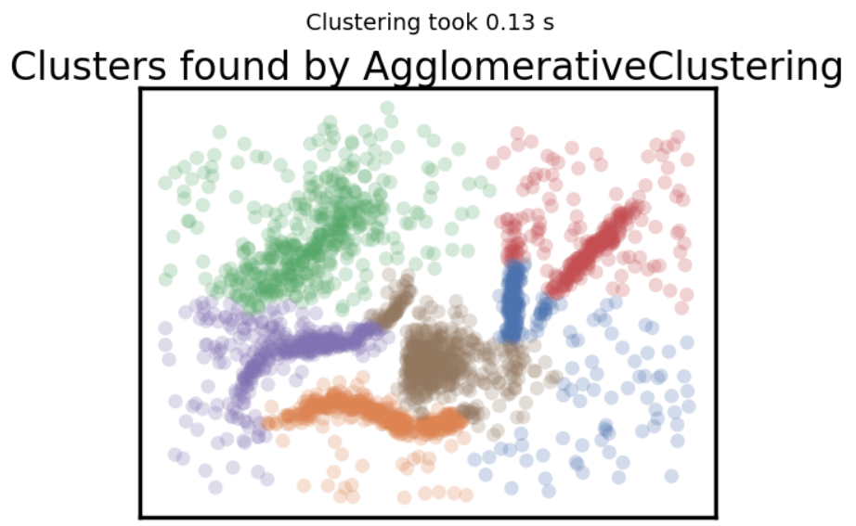

We are able to cluster the thin clusters better than other algorithms but still have clusters containing some parts of other clusters embedded into it, but the mis-clustering’s are smaller as compared to spectral clustering. We still have the noisy data which is polluting the cluster. Overall, we can get some good intuition from the plot despite its misclustering and noisy data.

Intra clustering distance is more because of outliers but the inter cluster distance is minimal as we have clusters bonded together.

## HDBSCAN:

**Don’t be wrong:** HDBSCAN scores the highest points for this segment as it has no varying cluster density issue.

**Intuitive Parameters:** Choosing a value formin_cluster_size is reasonably easy and intuitive whereas choosing min_samples is not that intuitive.

**Stability:** HDBSCAN has good stability over runs and parameter choices.

**Performance:** HDBSCAN is very efficient and can be scaled significantly and still achieves good results.

**Best Params:**



The two important parameters are min_cluster_size which defines the minimum no of datapoints needed to form a cluster and min_samples that helps change the density.The optimal values chosen are 50 and 10 after multiple trails and the best cluster selection method is ‘eom’

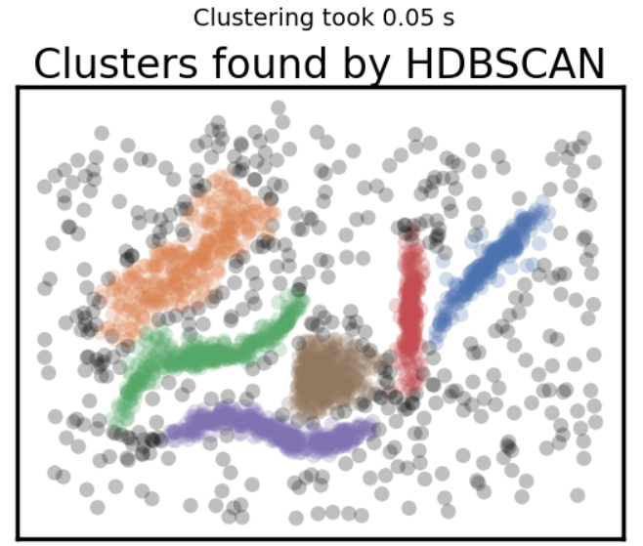

The Cluster plot explains a lot as we can see clusters are defined very clearly and match the clusters we see with our eyes and the noisy points are discarded while grouping the clusters making it a best algorithm over others.

The clusters are dense and tightly clustered which means intra cluster variations are less and we also see inter cluster variations are also lesser.

# References

HDBSCAN*¶, P. s. f., 2023. *Parameter Selection for HDBSCAN* - hdbscan 0.8.1 documentation.* [Online]   
Available at: https://hdbscan.readthedocs.io/en/latest/parameter_selection.html#  
[Accessed 1 May 2023].

Metrics¶, D., 2023. *Basic Usage of HDBSCAN* for Clustering¶.* [Online]   
Available at: https://hdbscan.readthedocs.io/en/latest/basic_hdbscan.html#what-about-different-metrics  
[Accessed 1st May 2023].

Probabilistic and Statistical Inference, G., 23. *Affinity Propagation FAQ.* [Online]   
Available at: http://genes.toronto.edu/affinitypropagation/faq.html  
[Accessed 1st May 2023].

sklearn.cluster.AffinityPropagation, 2023. *scikit.* [Online]   
Available at: https://scikit-learn.org/stable/modules/generated/sklearn.cluster.AffinityPropagation.html  
[Accessed 1st May 2023].

sklearn.cluster.AgglomerativeClustering, 2023. *scikit.* [Online]   
Available at: https://scikit-learn.org/stable/modules/generated/sklearn.cluster.AgglomerativeClustering.html  
[Accessed 1 May 2023].

sklearn.cluster.KMeans, 2023. *scikit.* [Online]   
Available at: https://scikit-learn.org/stable/modules/generated/sklearn.cluster.KMeans.html  
[Accessed 1st May 2023].

sklearn.cluster.MeanShift, 2023. *scikit.* [Online]   
Available at: https://scikit-learn.org/stable/modules/generated/sklearn.cluster.MeanShift.html  
[Accessed 1st May 2023].

sklearn.cluster.SpectralClustering, 2023. *scikit.* [Online]   
Available at: https://scikit-learn.org/stable/modules/generated/sklearn.cluster.SpectralClustering.html  
[Accessed 1 May 2023].

Spectral Clustering, M., 2023. *GeeksforGeeks.* [Online]   
Available at: https://www.geeksforgeeks.org/ml-spectral-clustering/  
[Accessed 1st May 2023].

Understanding Mean Shift Clustering, M., 2023. *Understanding Mean Shift Clustering and Implementation with Python.* [Online]   
Available at: https://towardsdatascience.com/understanding-mean-shift-clustering-and-implementation-with-python-6d5809a2ac40  
[Accessed 1 May 2023].